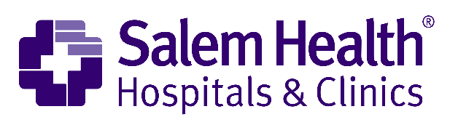

2022 ONE-YEAR COMMUNITY INVESTMENT
APPLICATION COVERLETTER

Application Organization

Project Title

Address

Contact Name

Phone

E-mail

Executive Signature

- Indicate the priority area that will be addressed with this project:

Behavioral Health
Substance Use and Prevention
Social Determinants of Health

- Provide a brief synopsis of your project (2-3 sentences are sufficient): _______________________________________________________________________________________________________________________________________________________________________________________________________________________________________________________________________________________________________________________________________________________________________________________

- Budget Breakdown:

Personnel
Supplies
Facility Costs
Other (explain below)
Administration (10% or less)
Total Request

Other (explain) ________________________________________________________________

- Approximate number of unduplicated individuals served by your project? ___________

- Narrative:
  - Project Abstract – 250 words
  - Description – No more than 5 pages
    - Need or problem to be address through this initiative?
    - How would the project have an impact on need or problem?
    - Who does the project serve?
    - What is the capacity of the applicant to carry out the project?
  - Project Logic Model – Form included
  - Evaluation Plan – 250 words
  - Project Suitability Plan – 250 words
    - Leveraged Resources – Grant requires a one-for-one match investment. Match can be funds or in-kind. In-kind is defined as real property, equipment, goods, or services contributed to the program/project that would be eligible costs that the grant would otherwise had to fund.
  - Budget and Budget Narrative – One page

- Timeline
  - Grant Cycle
    - Grant Opens April 5, 2021
    - Grant Submission Deadline May 7, 2021
    - Grant Award Notification June 11, 2021
    - Grant Funding Begins July 1, 2021
    - Final Report August 30, 2022

- Submission
Email PDF application document to community.relations@salemhealth.org no later than midnight May 7, 2021 to be considered.
- Incomplete applications will not be accepted
- Applications date stamped after midnight May 7th will not be accepted

