Utilizing the Wi-Fi Network

Complete the following steps:

1. Open up Wi-Fi settings
2. Select the “SalemHealth-Guest” network
3. Review the Terms & Conditions
4. Select the option on the right, as below.

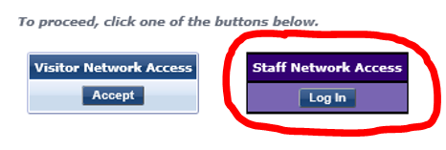

1. You will be prompted to enter your Salem Health Username and Password.

*For Apple Device Users Only*

1. Under the Wi-Fi settings, click on the SalemHealth-Guest network.
2. Ensure both the Auto-Join and Auto-Login features are on (see the image below).

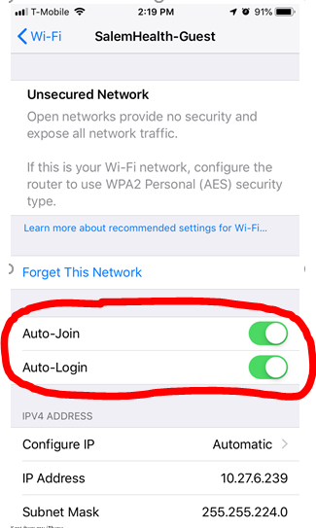

1. You are all set!

Wi-Fi Calling Tip Sheet

Salem Health IT recommends enabling Wi-Fi calling on your phone for an improved call making experience while on campus. Wi-Fi calling can be used to supplement limited or non-existent cell signal, however, it isn’t automatically enabled on smartphones. All major cell phone carriers offer Wi-Fi calling, with support for the recent iPhones and Android phones. Follow the phone and carrier specific instruction below to activate Wi-Fi calling, once active you can dial or text as usual.

If you experience any difficulties enabling or using Wi-Fi calling, please contact your service provider.

**iPhone**

Settings > Cellular > Wi-Fi Calling and then toggle on Wi-Fi Calling on This Phone.

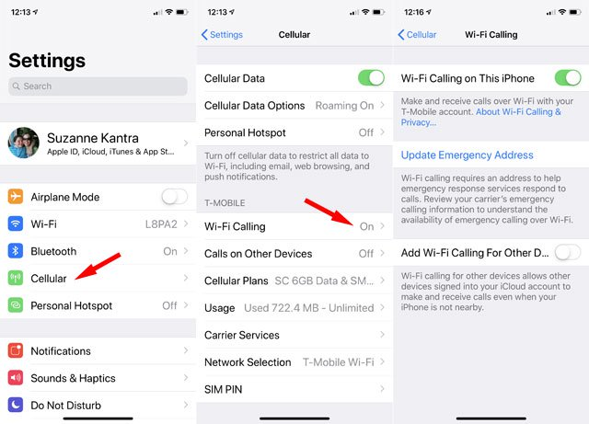

**Android**

Settings > Networks & Internet > Mobile network > Advanced > Wi-Fi Calling.

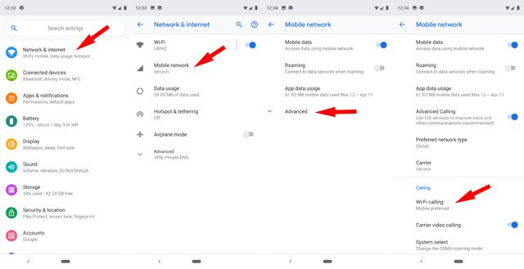

**More Questions**

Please contact the Salem Health Service Desk at 503-814-4357 (4-HELP) if you have any questions.