Questions or concerns:
New Laboratory Test
Respiratory Pathogen Panel (RPP)

Body copy is set to Times New Roman 11 point. Pellentesque diam lorem, pellentesque sed dignissim et,

The current Respiratory Panel (RVPM, LAB7079) is being replaced by the Respiratory Pathogen Panel (RPP, LAB7107) starting 09/26/2019.

The Respiratory panels are PCR based tests for multiple respiratory pathogens. Both are tested from NP swabs. The laboratory is switching to new instrumentation to facilitate a faster turnaround time.

Specimen collection, transport and stability will remain the same. Only nasopharyngeal swabs submitted in viral transport media can be tested.

The new test will not have Bordetella pertussis (available as a send out test, LAB3059), and Coronavirus will not be typed. The pathogens tested are as follows:

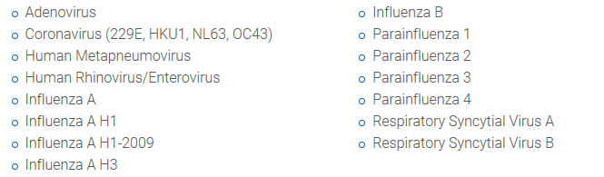

Renee Gerros, MT (ACSP)
Senior Specialist Microbiology

SALEM HEALTH
3300 State St., Salem OR 97301
503-814-1640
renee.gerros@salemhealth.org

