The Salem Hospital blood bank will be introducing pathogen-reduced; psoralen-treated platelets on Sept.1,2019. We will be phasing in these new platelets into our inventory based on available supply from our blood center. The following points supported the decision to adopt these new platelet products.

- The Traditional Approach to Blood Safety Is Reactive
- Blood is tested for a limited number of pathogens with current testing methods.
- New pathogens continue to emerge, and tests for all new pathogens do not currently exist.
- Bacterial contamination is the leading transfusion-transmitted infection (TTI) and can lead to sepsis and/or death.
- Transfusion reactions including sepsis may be under recognized and underreported.
- PATHOGEN REDUCTION (or PSORALEN TREATMENT) is a Proactive Approach to Blood Safety
  - Reduces the risk of transfusion-transmitted infection (TTI), including sepsis, in platelet recipients.
  - Pathogen reduction via psoralen and UVA light treatment is effective in mitigating CMV and is a proactive approach to reducing the risk of CMV transmission.
  - Like irradiation, the psoralen/UVA light treatment pathogen reduction process inactivates T cells in platelets, potentially lowering the risk of TA-GVHD.
  - Platelets that have been pathogen reduced by psoralen treatment and UVA do not need to be irradiated. The AABB standard 5.19.3.1 for irradiation of blood products considers the FDA-approved method of pathogen reduction equivalent to irradiation. http://standards.aabb.org/pages/external/standard.aspx?catalogId=12)

- PATHOGEN REDUCTION has a Strong History of Development and Routine Use
  - INTERCEPT treated platelets can be used for all standard indications in adults and children, with no exclusions.
  - Products like albumin, IVIG, and others derived from plasma such as blood clotting factors used to treat hemophilia also undergo a form of pathogen reduction when they are manufactured from human plasma donations to minimize risk to the patients receiving these products.
  - Extensive European hemovigilance programs include data on platelets that have undergone psoralen/UVA pathogen reduction prior to transfusion in various patient populations⁽¹⁹⁻²⁷⁾ showing no unexpected adverse events reported across multiple age ranges including neonates, infants, children and adults across multiple disease states.
  - >12 years of routine use in >100 centers in multiple countries outside the US with >4 million processing sets distributed for use in pathogen-reduction.
  - Extensive preclinical toxicology program was conducted per FDA product safety standards on the specific psoralen used in the psoralen/UVA light treatment pathogen reduction process. To date, no documented sensitivity to this psoralen known as amotosalen has been reported.
  - Robust clinical studies were conducted in the US showing effectiveness and safety; ⁽¹⁻¹⁸⁾
  - Pathogen-reduced, psoralen-treated platelets were approved by the FDA in December 2014 and are in routine use in US hospitals.

- PSORALEN-TREATED PLATELET ADMINISTRATION
  - Platelet dosing and volume of the new psoralen-treated platelets are the same as conventional platelet products.
  - Pre-medication and hang time for psoralen-treated platelets are the same as conventional platelet products.
  - Patients may receive both conventional platelets and psoralen-treated platelets to fill their transfusion requirements.
  - Psoralen-treated platelets can be transfused in the same tubing as conventional platelets when patients require multiple doses of platelets filled with both types of platelets. There is no interaction when transfusion a conventional platelet or a psoralen treated platelet in the same line.
- PSORALEN-TREATED PLATELET BAG APPEARANCE
  - The new psoralen-treated platelet bags are 2.8 inches longer than conventional platelet products.
  - INTERCEPT BLOOD SYSTEM is embossed across the top of the bag.
  - All psoralen-treated platelets are leukoreduced and equivalent to irradiated platelets

CONVENTIONAL PLATELET PSORALEN-TREATED PLATELET
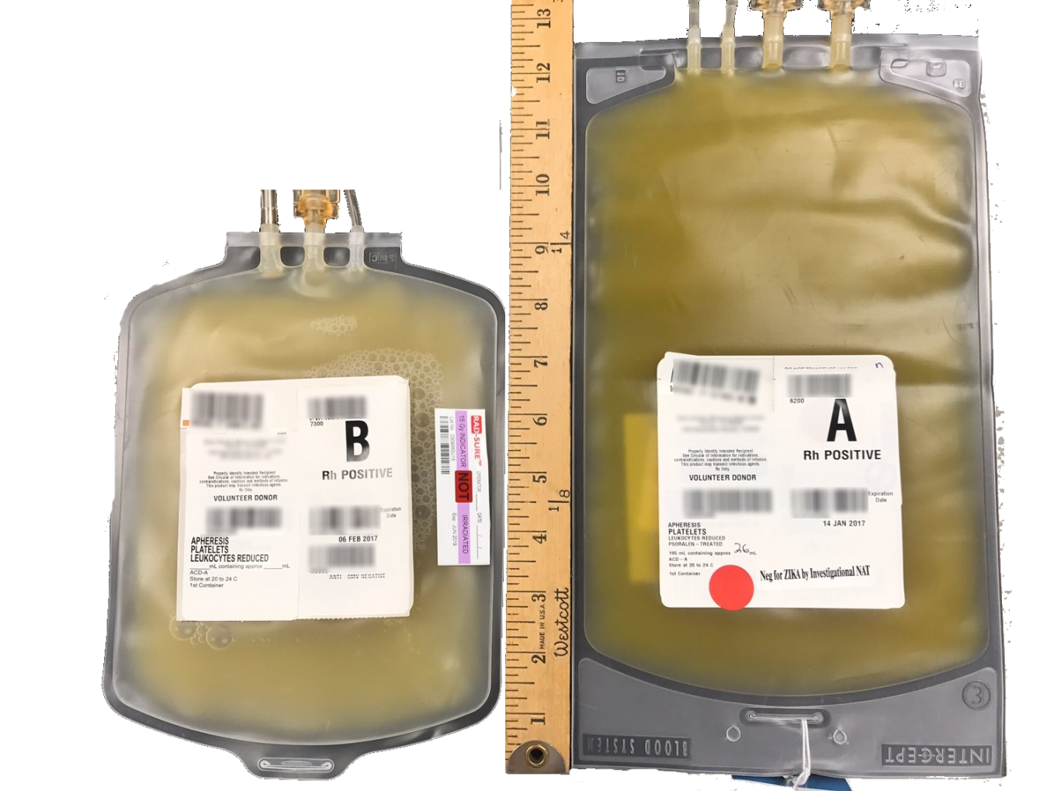

- PSORALEN-TREATED PLATELET LABEL
  - Labeled as APHERESIS PLATELETS PAS-C ADDED LEUKOCYTES REDUCED
  - Key words to look for on the new platelet labels - PSORALEN-TREATED which indicates that this product has undergone the psoralen + UVA light treatment process to inactivate pathogens.

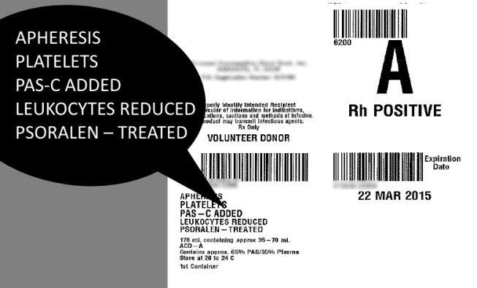
30 SEPT 2018

  - Platelets that have been psoralen treated will not require irradiation. The AABB standard 5.19.3.1 for irradiation of blood products considers the FDA-approved psoralen-treated method of pathogen reduction equivalent to irradiation. http://standards.aabb.org/pages/external/standard.aspx?catalogId=12)
  - As the psoralen-treated platelets do not require irradiation there will NOT be a Rad-Sure™ sticker on the bag. No irradiation will be performed on psoralen-treated platelets.

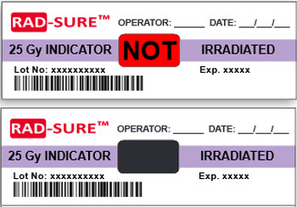

- An Additional tie tag will be attached to the unit:

APHERESIS PLATELETS
PAS-C ADDED
LEUKOCYTE REDUCED PSORALEN TREATED
ARE EQUIVALENT TO AN IRRADIATED CMV NEG PLATELET
IN ADDITION BACTERIA ARE INACTIVATED
IRRADIATION NOT NEEDED

REFERENCES
- The Intercept Blood System for Plasma Package Insert, August 2015.
- The Intercept Blood System for Platelets Package Insert, March 15, 2016.
- Prowse, C.V., Component Pathogen Inactivation; a critical review. Vox Sanguinis, 2012. DOI: 10.1111/j.1423-0410.
- Snyder, E, T Raife, et al., Recovery and Lifespan of 111 Indium radiolabeled platelets treated with pathogen inactivation using amotosalen HCl (S-59) and UVA light. Transfusion, 2004. 44: p. 1732-1440.
- Corash, L, V Paton, et al., S-59 clearance and kinetics after transfusion of platelets treated with Helinx™ Technology. Transfusion, 2000. 40(S10): p. 137.
- Slichter, SJ, TJ Raife, et al., Platelets photochemically treated with amotoslaen HCl and ultraviolet A
light correct prolonged bleeding times in thrombocytopenic patients. Transfusion, 2006. 46
- McCullough, J, DH Vesole, et al., Therapeutic efficacy and safety of platelets treated with a photochemical process for pathogen inactivation: the SPRINT Trial. Blood, 2004. 104(5): p. 1534-41.
- Janetzko, K, JP Cazenave, et al., Therapeutic efficacy and safety of photochemically treated apheresis platelets processed with an optimized integrated set. Transfusion, 2005. 45(9): p. 1443-1452.
- Schlenke, P, W Hagenah, et al., Safety and clinical efficacy of platelet components prepared with pathogen inactivation in routine use for thrombocytopenic patients. Ann Hematol, 2011. 90(12): p. 1457-65.
- Infanti, L, C Stebler, et al., Pathogen-inactivation of platelet components with the PATHOGEN REDUCTION Blood
System : a cohort study. Transfus Apher Sci, 2011. 45(2): p. 175-81.
- van Rhenen D J, H Gulliksson, et al., Transfusion of pooled buffy coat platelet components prepared with photochemical pathogen inactivation treatment: the euroSPRITE trial. Blood, 2003. 101: p. 2426-2433.
- Slichter, SJ, RM Kaufman, et al., Dose of prophylactic platelet transfusions and prevention of hemorrhage. N Engl J Med, 2010. 362: p. 600-613.
- Sigle, JP, L Infanti, et al., Comparison of transfusion efficacy of amotosalen-based pathogen-reduced platelet components and gamma-irradiated platelet components. Transfusion, 2013. 53(8): p. 1788-97
- Hambleton J, et al., (2002), Transfusion. 42(10): p. 1302-7.
- Mintz PD, et al., (2006), Blood. 107(9): p. 3753-60.
- de Alarcon P, et al., (2005), Transfusion. 45(8): p. 1362-72.
- Mintz PD, et al., (2006), Transfusion. 46(10): p. 1693-704.
- Herbrecht R, et al., (2012), Vox Sanguinis. 103(Suppl.1): p. 245.
- Cinqualbre J, et al., (2012), Vox Sang. 103(Supplement 1): p. 247-248. Cinqualbre J, Kientz D, et al., (2015). Transfusion, accepted for publication.
- Agence Francaise de Securite Sanitaire des Produits de Sante, Rapport Annuel Hemovigilance, in Rapport
- Annuel Hemovigilance 2009, 2010, 2011
- Swissmedic, Haemovigilance Annual Report, 2010, 2011, 2012, 2013, 2014, 2015
- Aubry, et al., Inactivation of Zika Virus in plasma with amotaslen and ultraviolet A illumination. Transfusion, 2015. doi:10.1111/trf.13271 p1-8

CONTRAINDICATIONS
Contraindicated for preparation of plasma or platelet components intended for patients with a history of hypersensitivity reaction to amotosalen or other psoralens. Contraindicated for preparation of plasma or platelet components intended for neonatal patients treated with phototherapy devices that emit a peak energy wavelength less than 425 nm, or have a lower bound of the emission bandwidth <375 nm, due to the potential for erythema resulting from interaction between ultraviolet light and amotosalen.
WARNINGS AND PRECAUTIONS
Only Intercept Processing Sets for plasma or platelets are approved for use in the Intercept Blood System. Use only the INT100 Illuminator for UVA illumination of amotosalen-treated plasma or platelet components. No other source of UVA light may be used. Please refer to the Operator’s Manual for the INT100 Illuminator. Discard any plasma or platelet components not exposed to the complete INT100 illumination process.Tubing components and container ports of the Intercept Blood System for Plasma or Platelets contain polyvinyl chloride (PVC). Di (2-ethylhexyl) phthalate (DEHP) is known to be released from PVC medical devices, and increased leaching can occur with extended storage or increased surface area contact. Blood components will be in contact with PVC for a brief period of time (approx. 15 minutes) during processing. The risks associated with DEHP released into the blood components must be weighed against the benefits of therapeutic transfusion.
PLATELETS
Pulmonary events: Acute Respiratory Distress Syndrome (ARDS)
Intercept processed platelets may cause the following adverse reaction: Acute Respiratory Distress Syndrome-(ARDS). An increased incidence of ARDS was reported in a randomized trial for recipients of Intercept processed platelets, 5/318 (1.6%), compared to recipients of conventional platelet components (0/327). Monitor patients for signs and symptoms of ARDS.

GLOBAL HEADQUARTERS | 2550 Stanwell Drive | Concord, CA US 94520 | 855.835.3523
www.cerus.com | www.intercept-usa.com
Rx only. There is no pathogen reduction process that has been shown to eliminate all pathogens. Certain non-enveloped viruses (e.g., HAV, HEV, B19 and poliovirus) and Bacillus cereus spores have demonstrated resistance to the Intercept process. See package insert for full prescribing information.

