Utilizing the Wi-Fi Network
Complete the following steps:
- Open up Wi-Fi settings
- Select the “SalemHealth-Guest” network
- Review the Terms & Conditions
- Select the option on the right, as below.
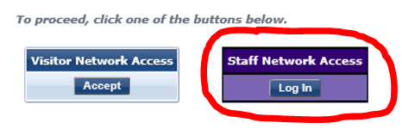
- You will be prompted to enter your Salem Health Username and Password.
For Apple Device Users Only
- Under the Wi-Fi settings, click on the SalemHealth-Guest network.
- Ensure both the Auto-Join and Auto-Login features are on (see the image below).
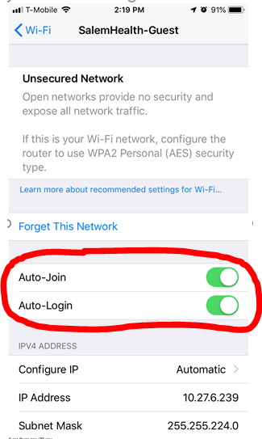
- You are all set!

Wi-Fi Calling Tip Sheet
Salem Health IT recommends enabling Wi-Fi calling on your phone for an improved call making experience while on campus. Wi-Fi calling can be used to supplement limited or non-existent cell signal, however, it isn’t automatically enabled on smartphones. All major cell phone carriers offer Wi-Fi calling, with support for the recent iPhones and Android phones. Follow the phone and carrier specific instruction below to activate Wi-Fi calling, once active you can dial or text as usual.
If you experience any difficulties enabling or using Wi-Fi calling, please contact your service provider.

iPhone
Settings > Cellular > Wi-Fi Calling and then toggle on Wi-Fi Calling on This Phone.
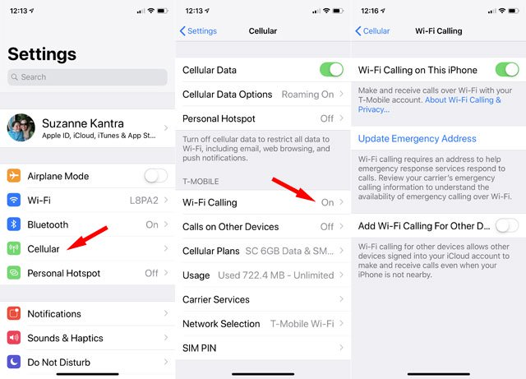

Android
Settings > Networks & Internet > Mobile network > Advanced > Wi-Fi Calling.
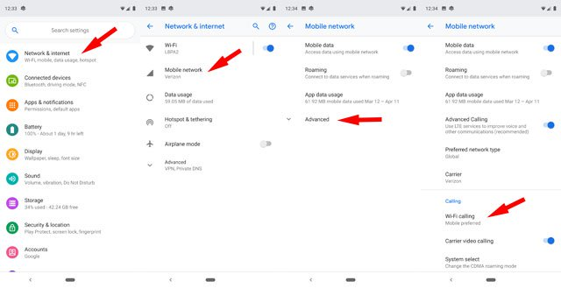
More Questions
Please contact the Salem Health Service Desk at 503-814-4357 (4-HELP) if you have any questions.

