Salem Health Avoids $1 – 1.2 million supply expense increase by signing with SURPASS!
So what is SURPASS?
SURPASS: Synergizing for Unparalleled Results in Procurement And Strategic Sourcing
Salem Health as part of our membership with Premier Inc. Group Purchasing Organization joined many other Healthcare systems across the country in an effort to reduce unwarranted clinical supply variation, and to drive deeper contract discounting. The effort called SURPASS, is designed to ensure clinical quality for our patients and reduce supply expenses at the same time.
SURPASS includes participation from:
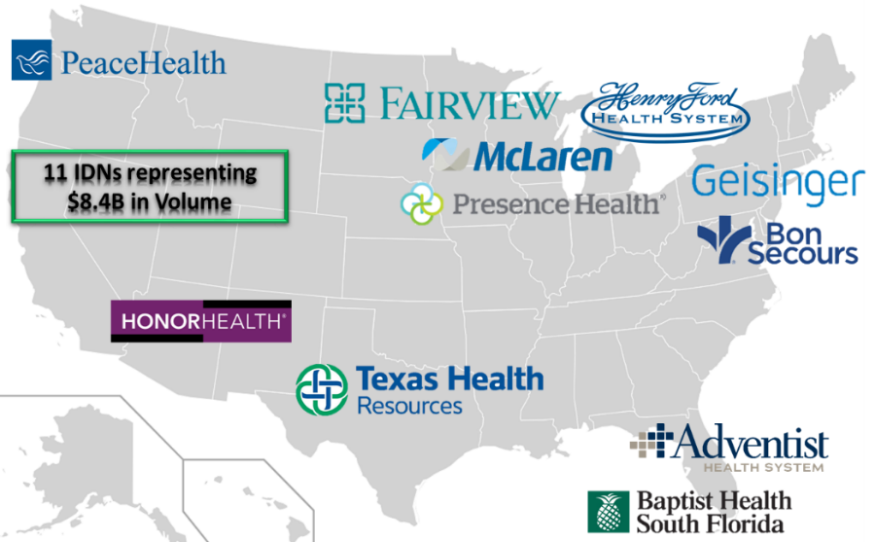

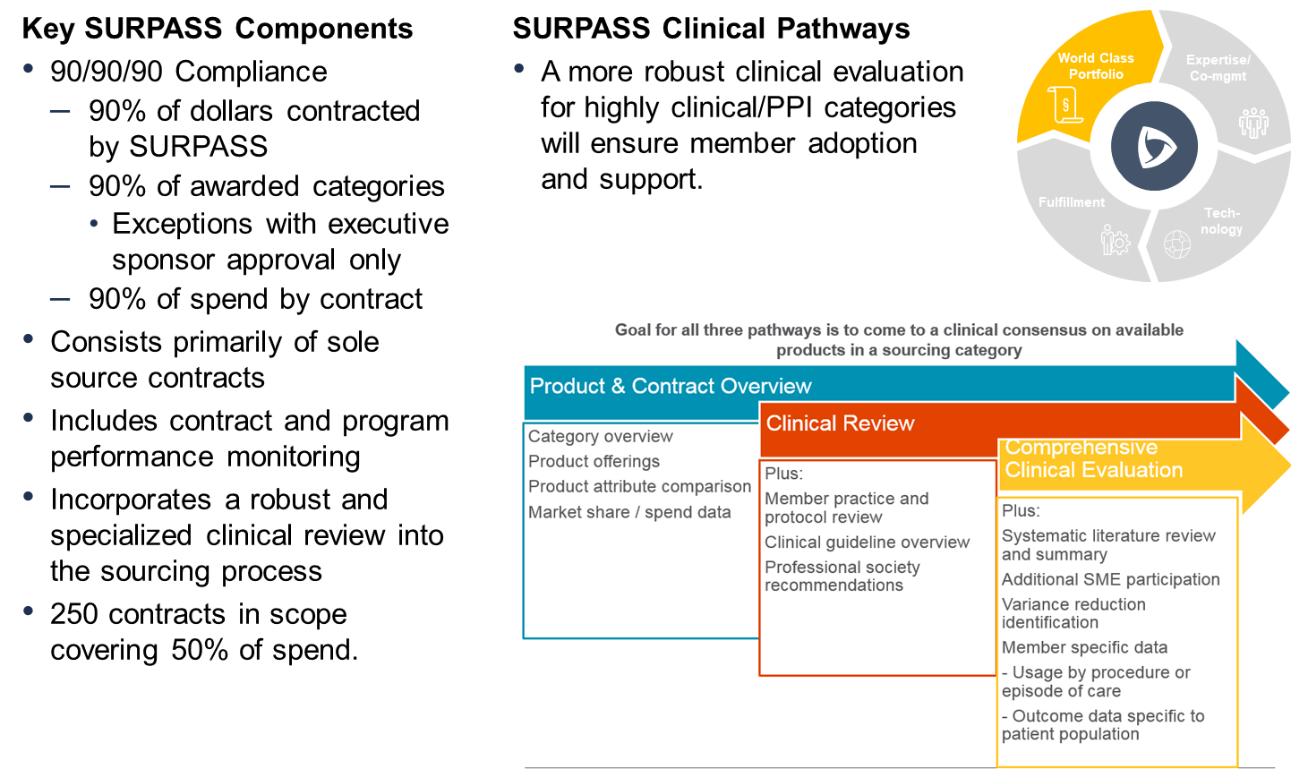
So what does this mean to Salem Health:
- This is a highly committed contracting environment which means we will enjoy deeper discounts for supplies, but will need to convert a number of product categories to match the SURPASS formulary to remain program compliant.
- 51 SURPASS contract launches since we enrolled starting January 1, 2019.
- Of those contracts, 26 were for products already in use, with an estimated annual savings of $367,000 annually.
- Conversions completed to date have saved roughly $75,000 (SCD sleeves alone will save $105k annually).
- An additional 21 product conversions are identified or in some phase of validation, with an estimated annual savings of $170,000 additional annual savings to Salem Health.

Total projected savings for this fiscal year will exceed $642,000 through this program, in addition to avoiding the $1 - 1.2 million dollar annual increase if we did not sign up in January 2019.
This LEAN work is not easy though and requires physicians and clinicians to engage with clinical supply trials and validations, taking particular care that we make good clinical decisions to ensure supplies are clinically acceptable and ensure excellent outcomes for our patients. Fortunately, all of the supplies are currently in use by other SURPASS members elsewhere in the country and are known to ensure excellent patient outcomes.
What can you do to support or participate? Please assist with supply trials and validations as they come through our products committees to ensure we meet our contract compliance requirements. Many supplies will be coming up for validation in the OR, Cath Lab, Nursing, and other clinical areas.
So when you hear this is a SURPASS initiative, please do your best to support.
If you would like more information or would like to become more involved in this work, please Email Karl Wright or Brooks Kary for more information. We look forward to hearing from you!

